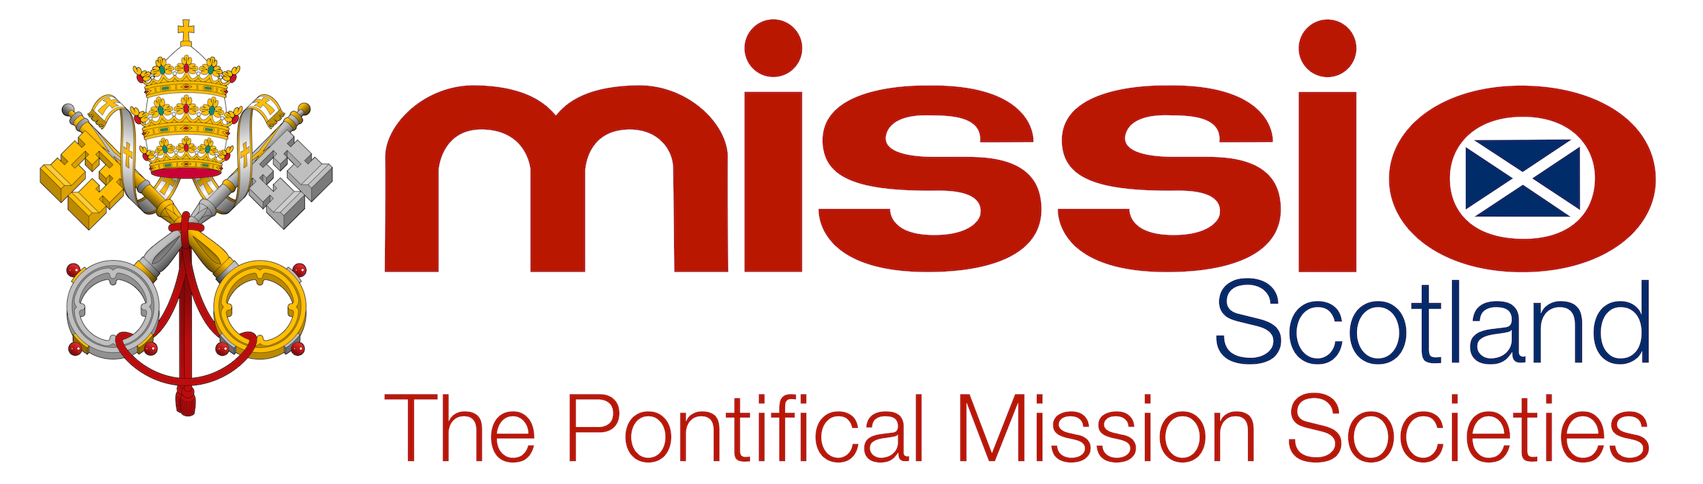

World Mission Sunday – 18th October 2020

Parish Collection Remittance

Please make all cheques payable to Missio Scotland and send to Missio Scotland using the freepost envelope enclosed.

Or send via BACS using your parish name and parish ID as the reference to:

Sort Code : 83-17-13 Account No : 14036020

Any completed gift aid forms should also be returned to us.

Please do not send cash.

PLEASE PRINT

NAME OF PARISH _______ ____________

PARISH ID _______ ____________

TOWN _______ ____________

DIOCESE _______ ____________

Mission Sunday Collection £……………………

Other £……………………

TOTAL £……………………

Feedback

If you wish to share any feedback, please use the space below.

_______________________________________________________________________________

_______________________________________________________________________________

_______________________________________________________________________________

_______________________________________________________________________________

Missio Scotland, 4 Laird Street, Coatbridge, ML5 3LJ
Tel: 01236 449774 Email: admin@missioscotland.com Website: www.missioscotland.com
Charity Number: SC014858

